SOCIAL STUDIES 9
Europe and North America to the mid-19th century
Ms. McDade
Fall 2016
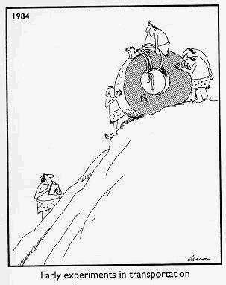

This year in grade 9, we will explore North American geography, first nations people of Canada, Europe between 1500-1850 CE and the events that ensued following the arrival of Europeans in North America. We will look at major revolutions and wars during this dynamic time. We will analyze human behavior, including our own, and will be keeping each other up to date on current events around the world.

During the semester, you will research chosen topics in teams and on your own. Assignments will involve both written and oral presentations. Smaller assignments (reading, note taking, worksheets, mapping, current event presentations, etc.) will be given throughout the semester. Most assignments are done in class, but students should expect to do some reading and complete unfinished assignments at home.

You, as a student, are required to recall, think critically, analyze and evaluate the materials provided in order to gain the knowledge and skills needed to advance to Social Studies 9.

Student Materials (required for each class):
- Text book – Crossroads: A Meeting of Nations
- Pen, pencil, eraser, highlighter
- Binder with paper and dividers
- USB memory stick

Evaluation:
- Assignments, projects, tests and quizzes 70%
- Final project 15%
- Final exam 15%

Expectations

- Be organized
- Be punctual
- Be prepared
- Be positive
- Be productive
- Participate
- Do class work/ homework
- Be respectful of people and space
- Be responsible for work/ time you have missed

Contact
If you or your parents have any questions or concerns, please send me an email at kathleen.mcdade@yesnet.yk.ca or call me at school at 667-8044. Updates will be posted to my webpage which can be accessed through the PCSS home page.

