Nom:

La Nourriture - 4
Core French 8

VOCABULAIRE

FRANÇAIS | ANGLAIS

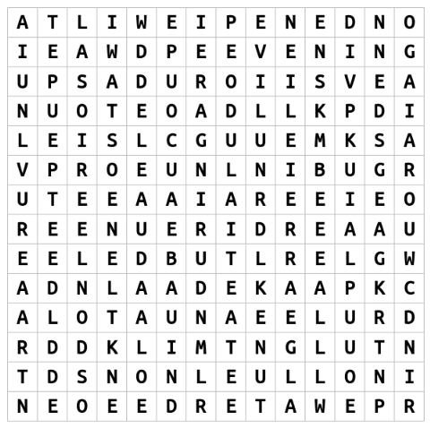

DICTÉE

A : ___________________________________________________________________________

______________________________________________________________________________

______________________________________________________________________________

______________________________________________________________________________

______________________________________________________________________________

______________________________________________________________________________

B : ___________________________________________________________________________

______________________________________________________________________________

______________________________________________________________________________

______________________________________________________________________________

______________________________________________________________________________

______________________________________________________________________________

2 sound/ symbol connection(s) I made : _____________________________________________

______________________________________________________________________________

2 sound/ symbol errors I made : __________________________________________________

______________________________________________________________________________

MESSAGE DU JOUR

Pendant la soirée d’Halloween, c’est important de boire pour s’hydrater. On marche beaucoup pour chercher des bonbons et c’est beaucoup de travail! Je bois souvent de l’eau avec le souper. Ma fille, Dorothy, boit souvent du lait avec le souper.

Answer the following questions (try for full sentences in French to reach extending!) :

- Quand est-ce que c’est important de boire pour s’hydrater? ______________________

______________________________________________________________________________

- Qu’est-ce que je bois souvent avec le souper? __________________________________

______________________________________________________________________________

- Qu’est-ce que Dorothy boit souvent avec le souper? _____________________________

______________________________________________________________________________

- Qu’est-ce que ça veut dire, « pendant » en anglais? _____________________________

______________________________________________________________________________

QUÉSTION DU JOUR

Question as I hear it:

Written question:

Sondage

Ms. McDade

Moi

Mon partenaire:

Write two sentences as shown in the example for both you and another classmate.

Exemple: Je préfère boire de l’eau avec le souper. Je préfère boire de l’eau plus que du lait.
Dorothy préfère boire du lait avec le souper. Elle préfère boire du lait plus que de l’eau.

Ma réponse : ___________________________________________________________________

______________________________________________________________________________

Un autre élève : _______________________________________________________________

_____________________________________________________________________________
Monster planning for tomorrow :

Name:

Pronouns:

Age:

Birthday:

Place of birth:

Eye colour:

Favourite colour:

2 characteristics:

Loves to eat (circle): fruit junk food

Likes to eat equally (2 items from above group):

*Does not like to eat:

*Detests eating:

*Favourite drink:

*Less preferred drink:

Usually eats snacks (circle): yes no

Always eats (circle): breakfast lunch dinner dessert

Sometimes/ rarely eats (circle): breakfast lunch dinner dessert

Never eats (circle): breakfast lunch dinner dessert

Other details:

AUTO-ÉVALUATION

MY BEHAVIOURS FOR SUCCESS FOR THIS COURSE WORK:
Behaviour | Self-assessment (circle)
Academic Responsibility: I seek help, complete assignments, set goals, self-assesses, accept feedback, take  ownership for my learning, I am organized | Consistently | Sometimes | Rarely
Engagement: I am ctive in learning, contributes to the classroom, work well with others | Consistently | Sometimes | Rarely
Conduct: I am respectful and focused | Consistently | Sometimes | Rarely

MY ACADEMIC ACHIEVEMENT:
Learning target 1: I ask and respond to questions in full sentences during question of the day and warm-up activities
EXTENDING (4) | PROFICIENT (3) | DEVELOPING (2) | EMERGING (1)
I speak without prompting and communicate my ideas clearly and confidently. | I use conversation structures provided and sometimes require prompting. | I use some modeled sentences and learned expressions and require a lot of prompting to do so. | I use words rather than sentences in my conversations.

Learning target 2: I can connect the sounds that I hear and the symbols that I write in a dictée exercize
EXTENDING (4) | PROFICIENT (3) | DEVELOPING (2) | EMERGING (1)
My written dictée mostly matched the actual written dictée. | I had some errors in my dictée but I made a lot of sound/ symbol connections. | My dictée and the actual written dictée have many differences. | My dictée and the actual written dictée look nothing alike

Learning target 3: I can write in full sentences using the expressions/ forms learned in class
EXTENDING (4) | PROFICIENT (3) | DEVELOPING (2) | EMERGING (1)
I write in full sentences using the expressions correctly and add additional details | I write in full sentences using the expressions correctly | I can write in full sentences with the correct expressions some of the time | I use only short sentences or words

Learning target 4: I understand what I read in the message du jour
EXTENDING (4) | PROFICIENT (3) | DEVELOPING (2) | EMERGING (1)
I fully comprehend the texts and subtle details. | I comprehend the general meaning of the texts. | I understand some parts of the texts. | I do not understand the texts.

