Nom:

La Nourriture - 3
Core French 8

VOCABULAIRE

FRANÇAIS | ANGLAIS

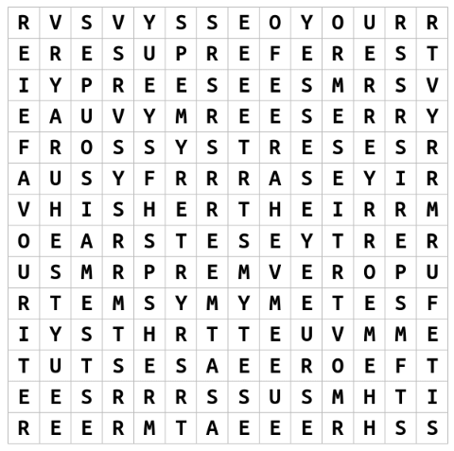
DICTÉE

A : ___________________________________________________________________________

______________________________________________________________________________

______________________________________________________________________________

______________________________________________________________________________

______________________________________________________________________________

______________________________________________________________________________

B : ___________________________________________________________________________

______________________________________________________________________________

______________________________________________________________________________

______________________________________________________________________________

______________________________________________________________________________

______________________________________________________________________________

2 sound/ symbol connection(s) I made : _____________________________________________

______________________________________________________________________________

2 sound/ symbol errors I made : __________________________________________________

______________________________________________________________________________

MESSAGE DU JOUR

L’Halloween est très amusant pour les enfants parce qu’ils peuvent chercher de la cochonnerie. Les Rockets sont mes bonbons d’Halloween préférés. Les Caramilks sont mes chocolats d’Halloween préférés. Dorothy adore les Skittles. Les Skittles sont ses bonbons préférés.

Answer the following questions (try for full sentences in French to reach extending!) :

- Quels sont mes bonbons d’Halloween préférés? ________________________________

______________________________________________________________________________

- Quels sont mes chocolats d’Halloween préférés? ________________________________

______________________________________________________________________________

- Est-ce que Dorothy aime les Skittles? _________________________________________

______________________________________________________________________________

- Ma fille s’appelle Dorothy. Quels sont ses bonbons d’Halloween préférés? ___________

______________________________________________________________________________

- Pourqoui est-ce que l’Halloween est très amusant pour les enfants? ________________

______________________________________________________________________________

______________________________________________________________________________

QUÉSTION DU JOUR

Question as I hear it:

Written question:

Sondage

 | Bonbons préférés | Chocolats préféres
Ms. McDade | Rockets | Caramilks
Moi

Use the survey information to write a paragraph with the following:

-Sentence 1: your name
-Sentence 2: your favourite Halloween candy
-Sentence 3: your favourite Halloween chocolate
-Sentence 4: the name of one of your classmates
-Sentence 5: that classmate’s favourite candy
-Sentence 6: that classmate’s favourite chocolate
Sentence 7: a statement using plus que, moins que or autant que comparing their
favourite candy to yours
-Sentence 8: a statement using plus que, moins que or autant que comparing their
favourite chocolate to yours

Exemple: Je m’appelle Ms. McDade. Mes bonbons d’Halloween préférés sont les Rockets. Mes chocolats d’Halloween préférés sont les Caramilks. Mon amie s’appelle Dorothy. Ses bonbons d’Halloween préférés sont les Skittles. Ses chocolats d’Halloween préférés sont les Cookies & Cream. J’aime les Skittles autant que les Rockets. J’aime les Cookies & Cream beaucoup moins que les Caramilks.

Ma paragraphe : _______________________________________________________________

______________________________________________________________________________

______________________________________________________________________________

______________________________________________________________________________

______________________________________________________________________________

______________________________________________________________________________

______________________________________________________________________________

______________________________________________________________________________

______________________________________________________________________________

______________________________________________________________________________

______________________________________________________________________________

______________________________________________________________________________

______________________________________________________________________________

______________________________________________________________________________

______________________________________________________________________________

______________________________________________________________________________

______________________________________________________________________________
AUTO-ÉVALUATION

MY BEHAVIOURS FOR SUCCESS FOR THIS COURSE WORK:
Behaviour | Self-assessment (circle)
Academic Responsibility: I seek help, complete assignments, set goals, self-assesses, accept feedback, take  ownership for my learning, I am organized | Consistently | Sometimes | Rarely
Engagement: I am ctive in learning, contributes to the classroom, work well with others | Consistently | Sometimes | Rarely
Conduct: I am respectful and focused | Consistently | Sometimes | Rarely

MY ACADEMIC ACHIEVEMENT:
Learning target 1: I ask and respond to questions in full sentences during question of the day and warm-up activities
EXTENDING (4) | PROFICIENT (3) | DEVELOPING (2) | EMERGING (1)
I speak without prompting and communicate my ideas clearly and confidently. | I use conversation structures provided and sometimes require prompting. | I use some modeled sentences and learned expressions and require a lot of prompting to do so. | I use words rather than sentences in my conversations.

Learning target 2: I can connect the sounds that I hear and the symbols that I write in a dictée exercize
EXTENDING (4) | PROFICIENT (3) | DEVELOPING (2) | EMERGING (1)
My written dictée mostly matched the actual written dictée. | I had some errors in my dictée but I made a lot of sound/ symbol connections. | My dictée and the actual written dictée have many differences. | My dictée and the actual written dictée look nothing alike

Learning target 3: I can write in full sentences using the expressions/ forms learned in class
EXTENDING (4) | PROFICIENT (3) | DEVELOPING (2) | EMERGING (1)
I write in full sentences using the expressions correctly and add additional details | I write in full sentences using the expressions correctly | I can write in full sentences with the correct expressions some of the time | I use only short sentences or words

Learning target 4: I understand what I read in the message du jour
EXTENDING (4) | PROFICIENT (3) | DEVELOPING (2) | EMERGING (1)
I fully comprehend the texts and subtle details. | I comprehend the general meaning of the texts. | I understand some parts of the texts. | I do not understand the texts.

Comments from Ms. McDade:

