Nom:

La Nourriture - 1
Core French 8

VOCABULAIRE

FRANÇAIS | ANGLAIS

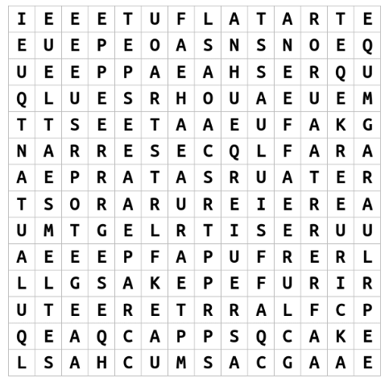
DICTÉE

A : ___________________________________________________________________________

______________________________________________________________________________

______________________________________________________________________________

______________________________________________________________________________

______________________________________________________________________________

______________________________________________________________________________

B : ___________________________________________________________________________

______________________________________________________________________________

______________________________________________________________________________

______________________________________________________________________________

______________________________________________________________________________

______________________________________________________________________________

Sound/ symbol connection(s) I made : _______________________________________________

______________________________________________________________________________

Sound/ symbol errors I made : ____________________________________________________

______________________________________________________________________________

MESSAGE DU JOUR

Hier soir, j’ai soupé chez mes voisins. Il y avait beaucoup d’options pour le dessert! J’ai mangé de la tarte. Ma fille, Dorothy, a mangé de la tarte et du gâteau! Je préfère manger de la tarte plus que du gâteau.

Answer the following questions (try for full sentences in French to reach extending!) :

- Where did I have supper last night? __________________________________________

______________________________________________________________________________

- Were there multiple options for dessert? _____________________________________

______________________________________________________________________________

- What did I eat for dessert? _________________________________________________

______________________________________________________________________________

- Who is Dorothy? _________________________________________________________

______________________________________________________________________________

- What did Dorothy eat for dessert? ___________________________________________

______________________________________________________________________________

- Do I prefer to eat pie or cake? _______________________________________________

______________________________________________________________________________

QUÉSTION DU JOUR

Question as I hear it:

Written question:

Sondage

Ms. McDade

Moi

Mon partenaire:

Exemple: Ms. McDade préfère manger de la tarte plus que le gâteau.

Une phrase complète selon moi : __________________________________________________

______________________________________________________________________________

Une phrase complète pour un autre élève : __________________________________________

_____________________________________________________________________________

LA LECTURE :

“J’ai Faim!” – Asking Questions in French

Ways to ask questions in French:

1)

2)

3)

4)

French question words:

Français | Anglais
Qu’est-ce que
Est-ce que
Comment
Où
Quand
Pourqoui
Combien
Qui
AUTO-ÉVALUATION

MY BEHAVIOURS FOR SUCCESS FOR THIS COURSE WORK:
Behaviour | Self-assessment (circle)
Academic Responsibility: I seek help, complete assignments, set goals, self-assesses, accept feedback, take  ownership for my learning, I am organized | Consistently | Sometimes | Rarely
Engagement: I am ctive in learning, contributes to the classroom, work well with others | Consistently | Sometimes | Rarely
Conduct: I am respectful and focused | Consistently | Sometimes | Rarely

MY ACADEMIC ACHIEVEMENT:
Learning target 1: I ask and respond to questions in full sentences during question of the day and warm-up activities
EXTENDING (4) | PROFICIENT (3) | DEVELOPING (2) | EMERGING (1)
I speak without prompting and communicate my ideas clearly and confidently. | I use conversation structures provided and sometimes require prompting. | I use some modeled sentences and learned expressions and require a lot of prompting to do so. | I use words rather than sentences in my conversations.

Learning target 2a: I can connect the sounds that I hear and the symbols that I write in a dictée exercize
EXTENDING (4) | PROFICIENT (3) | DEVELOPING (2) | EMERGING (1)
My written dictée mostly matched the actual written dictée. | I had some errors in my dictée but I made a lot of sound/ symbol connections. | My dictée and the actual written dictée have many differences. | My dictée and the actual written dictée look nothing alike

Learning target 2b: I can connect the symbols that I read and the sounds that I say when reading aloud
EXTENDING (4) | PROFICIENT (3) | DEVELOPING (2) | EMERGING (1)
I read familiar words without hesitation and can sound out most unfamiliar ones. | I read many familiar words and can sound out some unfamiliar ones. | I have difficulty in connecting sounds to symbols when reading in French. | I am unable to connect sounds to symbols when reading in French.

Learning target 3: I understand what I read in the message du jour and J’ai Faim story
EXTENDING (4) | PROFICIENT (3) | DEVELOPING (2) | EMERGING (1)
I fully comprehend the texts and subtle details. | I comprehend the general meaning of the texts. | I understand some parts of the texts. | I do not understand the texts.

Comments from Ms. McDade:

