Name:

Lost Pet Poster
Core French 8 – McDade
INTRODUCTION

You get to create a poster for a lost pet as a way to learn some new vocabulary about animals in French. You can pick any type of animal you want as a pet. Fill out the template below using Google translate or wordreference.com to look up unknown words and search up word you want to use to fill in the blanks. The example for the lost hippopotamus shows how to turn the template into a paragraph on your poster.
- You only need 5 traits and some will not apply to animals that don’t have feathers, scales, fins etc.
- For the underlined words in the template, pick either masculine or feminine depending on your animals (e.g. le chien is masculine so use mon/ il, la perruche is feminine so use ma/ elle)

TEMPLATE

Perdu!

J’ai perdu mon/ma _________________________. Il/ elle s’appelle _____________________________.

Il/ elle a une tête ___________________, les oreilles ___________________, les yeux ___________________,
un nez ___________________, une bouche ___________________, les dents ___________________, un bec ___________________, une queue ___________________, la fourrure ___________________, les plumes ___________________, la coquille ___________________, les écailles ___________________, le jambes ___________________, les pattes ___________________, les bras ___________________, les griffes ___________________, et les nageoires ___________________.

Si vous le trouvez, s’il vous plaît le retourner à __________________________________________.

Merci!

EXAMPLE

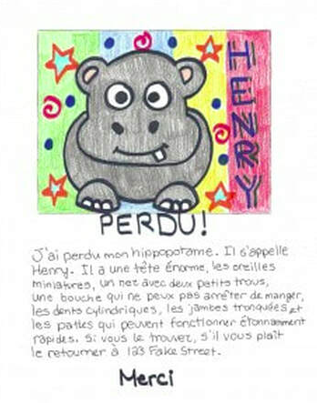

CHECKLIST

I have included the following on my poster
- My name
- A minimum of 5 different physical traits to describe my animal
- Correct French spelling
- A picture of my lost pet
- Neat colouring and writing

Name:

