Nom:

L’Halloween!
Core French 8

VOCABULAIRE

FRANÇAIS | ANGLAIS

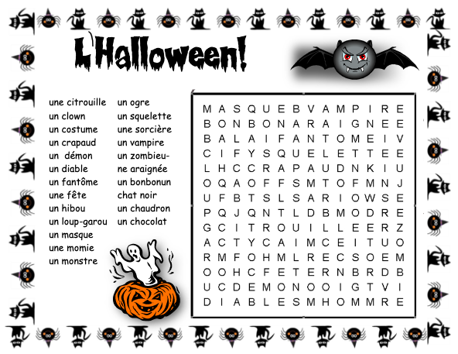

QUÉSTION DU JOUR

Written questions:

Sondage

Ms. McDade | une abeille
Moi

Mon partenaire:

Write two sentences as shown in the example for both you and another classmate.

Exemple: Mon déguisement pour l’Halloween est une abeille.
Ms. McDade est une abeille pour l’Halloween.
Je n’ai pas un déguisement pour l’Halloween.

Ma réponse : ___________________________________________________________________

______________________________________________________________________________

Un autre élève : _______________________________________________________________

_____________________________________________________________________________
LES MAISON HANTEÉES

Mon dessin:

Haunted places in France (name and brief description):

- ________________________________________________________________________

______________________________________________________________________________

______________________________________________________________________________

- ________________________________________________________________________

______________________________________________________________________________

______________________________________________________________________________

MY BEHAVIOURS FOR SUCCESS FOR THIS COURSE WORK:
Behaviour | Self-assessment (circle)
Academic Responsibility: I seek help, complete assignments, set goals, self-assesses, accept feedback, take  ownership for my learning, I am organized | Consistently | Sometimes | Rarely
Engagement: I am ctive in learning, contributes to the classroom, work well with others | Consistently | Sometimes | Rarely
Conduct: I am respectful and focused | Consistently | Sometimes | Rarely

MY ACADEMIC ACHIEVEMENT:
Learning target 1: I ask and respond to questions in full sentences during question of the day and warm-up activities
EXTENDING (4) | PROFICIENT (3) | DEVELOPING (2) | EMERGING (1)
I speak without prompting and communicate my ideas clearly and confidently. | I use conversation structures provided and sometimes require prompting. | I use some modeled sentences and learned expressions and require a lot of prompting to do so. | I use words rather than sentences in my conversations.

Learning target 3: I can write in full sentences using the expressions/ forms learned in class
EXTENDING (4) | PROFICIENT (3) | DEVELOPING (2) | EMERGING (1)
I write in full sentences using the expressions correctly and add additional details | I write in full sentences using the expressions correctly | I can write in full sentences with the correct expressions some of the time | I use only short sentences or words

Learning target 5: I engage in cultural activities
EXTENDING (4) | PROFICIENT (3) | DEVELOPING (2) | EMERGING (1)
I am fully engaged when watching movies in French, doing art projects in French and learning about French culture | I am mostly engaged when watching movies in French, doing art projects in French and learning about French culture | I am somewhat engaged when watching movies in French, doing art projects in French and learning about French culture | I am not engaged when watching movies in French, doing art projects in French and learning about French culture

