Graphing Assignment
Ms. McDade

Use the information from page 6 of the topic 1.1 worksheet to create a line graph according to the following instructions:

- Open Microsoft Excel
- Input data into cells starting at A1 as you see it on the data table
- Select columns 2, 3 and 4 (height A, height B and height C)
- Click the “insert” tab on the top green bar of excel
- Select the line graphic and click “line”
- Select columns 2, 3 and 4 again and try the “3D line” option
- Decide which graph you prefer and add a comprehensive title
- Under the chart design tab on the top green bar select “add chart element” and add “axis titles” - primary horizontal and primary vertical with units in brackets
- Delete legends you deem unnecessary and resize as needed.
- Copy and paste your graph into a word document.

Create as many of the following graphs as you can afterwards and add them to your word document. Include your name on the document, print it and hand it in. Please use as little paper as possible.

LINE GRAPHS

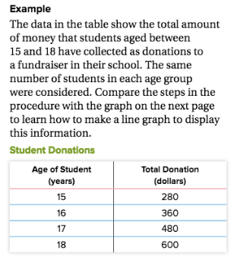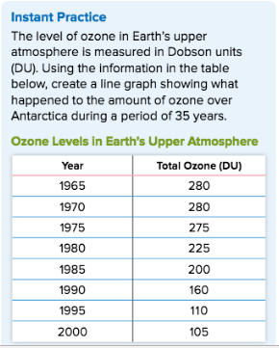

BAR GRAPHS

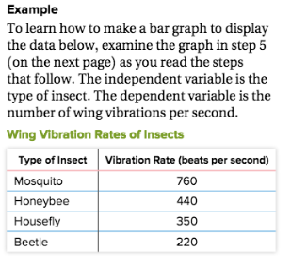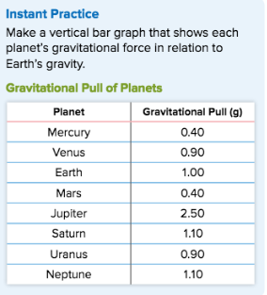

CIRCLE (PIE) GRAPHS

