Valentine’s Day Compound 1

Name: oxytocin

Formula: C₄₃H₆₆N₁₂O₁₂S₂

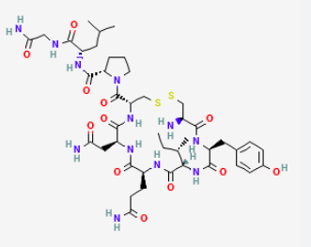

Description: The attachment love hormone/ cuddle chemical that is responsible for making you feel warm and fuzzy

Task: Link arms with your partner and feel how your pituitary gland releases oxytocin into your blood stream for warm fuzzy goodness

Valentine’s Day Compound 2

Name: dopamine

Formula: C₈H₁₁NO₂

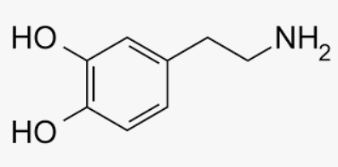

Description: the attraction love hormone that is released by your brain in high levels when you are attracted to someone

Task: close your eyes and think of someone you are attracted to and feel how neurons at the base of your brain convert the amino acid tyrosine into dopamine

Valentine’s Day Compound 3

Name: cinnamaldehyde

Formula: C₉H₈O

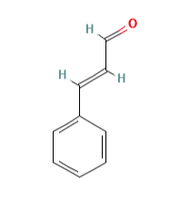
Description: cinnamaldehyde occurs naturally in the bark of cinnamon trees and gives cinnamon its flavour and odor; it has been shown to repel adult mosquitoes; it has antifungal and antibacterial properties; it is also an anti-inflammatory agent

Task: drink some Bengal spice tea and sense the cinnamaldehyde entering your stomach, crossing your small intestine wall to enter your bloodstream then move to ease the inflammation in your cross-country ski muscles

Valentine’s Day Compound 4

Name: theobromine (xantheose)

Formula: C₇H₈N₄O₂

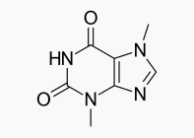

Description: theobromine is a bitter-tasting stimulant found in chocolate; dogs can not break this compound down in their bodies which is the reason chocolate is so dangerous for dogs; dark chocolate contains more theobromine than milk chocolate; its chemical structure is almost identical to caffeine which contains one more carbon and three more hydrogens but theobromine is a more mild and less addictive than caffeine; theobromine does not contain any bromine atoms

Task: Eat one piece of dark chocolate and one piece of milk chocolate. Which one do you prefer? Which one is more bitter? Which one has more theobromine?

Valentine’s Day Compound 5

Name: sodium bicarbonate

Formula: NaHCO₃

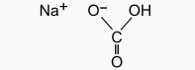

Description: Love Hearts are an iconic Valentine’s Day candy. They contain sodium bicarbonate (i.e. baking soda) that reacts with acid in the candy upon contact with water to produce a fizzy feeling in your mouth.

Task: Imagine eating a love heart candy and it fizzing in your mouth. These candies were the inspiration for this activity but Ms. McDade looked all over Whitehorse and couldn’t find any. Eat a Mentos instead. They contain a different compound – potassium hydroxide (KOH) which is used as a thickener and stabilizer in foods. Potassium hydroxide (aka potash or lye) is also a really great cleaning agent and plays an important part in soap making processes

Valentine’s Day Compound 6

Name: glucose

Formula: C₆H₁₂O₆

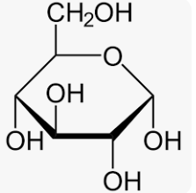

Description: Glucose is a type of sugar molecule. It is involved in a process called cellular respiration that takes place in the mitochondria of your body’s cells in order to generate energy. Different types of sugar are used to make candy and one of them is often glucose. High amounts of glucose in the blood require your pancreas to secrete insulin to move the sugar molecules into your cells.

Task: Eat a gummy bear. Feel the glucose entering your bloodstream. Thank your pancreas for moving the glucose molecules to your cells that need energy. Thank those cells’ mitochondria for their hard work provide you with energy through cellular respiration.

Valentine’s Day Compound 7

Name: vanillin

Formula: C₈H₈O₃

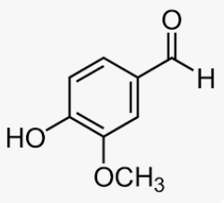

Description: Vanillin is the compound that gives vanilla its distinct smell and taste. Vanillin is an important aspect of many baked goods. The vanillin itself has many potential health benefits. The other ingredients in baked goods not so much.

Task: Eat a cookie and see if you can smell/ taste the vanillin.

Valentine’s Day Compound 8

Name: geraniol

Formula: C₁₀H₁₈O

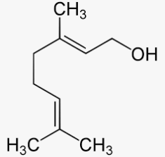

Description: Gerianol is the main compound that makes up the distinctive scent of roses. It has a wide spectrum of potential pharmacological activities including antimicrobial, anti-inflammatory, antioxidant, anti-cancer and neuroprotective. Studies involving students who interact with rose-scented incense outperform the students who were not exposed to the incense.

Task: Take a rose petal, rub it between your fingers and smell the gerianol compound that is released. Feel your brain’s ability to retain new information soar.

