Nom:

La Nourriture - 7
Core French 8

VOCABULAIRE

FRANÇAIS | ANGLAIS

NOMS MASCULINS NOM FÉMININ VERBES ADJECTIF

- - - -

- -
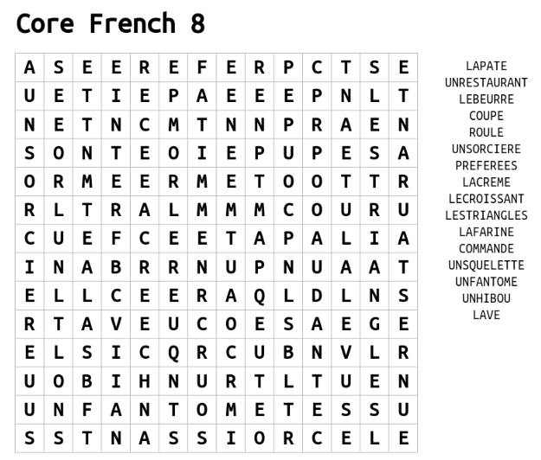
DICTÉE

A : ___________________________________________________________________________

______________________________________________________________________________

______________________________________________________________________________

______________________________________________________________________________

______________________________________________________________________________

______________________________________________________________________________

B : ___________________________________________________________________________

______________________________________________________________________________

______________________________________________________________________________

______________________________________________________________________________

______________________________________________________________________________

______________________________________________________________________________

- 2 sound/ symbol connection(s) I made : _______________________________________

______________________________________________________________________________

- 2 sound/ symbol errors I made : _____________________________________________

______________________________________________________________________________

- Underline the 5 nouns. Circle the 4 verbs. Put a cloud shape around around the three adverbs.

MESSAGE DU JOUR

Je mange parfois au restaurant. Mon restaurant préféré est The Wayfarer Oyster House. Je mange rarement du fast-food. Je préfère A&W plus que McDonalds.

- Given what you know about French, translate the message du jour into English:

______________________________________________________________________________

______________________________________________________________________________

______________________________________________________________________________

______________________________________________________________________________

- There is one adjective in the message du jour. What is it? _________________________

- There is one adjective in the vocabulary words this week. What is it? _______________

- An adjective is a word/ phrase that modifies a _____________________

- In French, adjectives can come _________________ or _________________ the words they modify.

- They give us more ______________________ about the words they modify

- Most adjectives come ___________________ the words they modify

- Adjectives in French need to correspond to _____________________ and the singular/ plural nature of the words they modify.

- Modifying Préféré(es)
  - Masculine singular noun/ pronoun: _________________________

  - Masculine plural noun/ pronoun: _________________________

  - Feminine singular noun/ pronoun: _________________________

  - Feminine plural noun/ pronoun: _________________________

Fill in the following table

Noun | Form of préréré(es) | Ma/ mon/ mes | Sentence
Un restaurant

Un fruit

Un legume

Une patisserie

Un dessert

Un déjeuner

Un diner

Un souper

Un collation

QUÉSTION DU JOUR

Written questions:

Sondage

 | Les croissants ou les pains au chocolat | A&W ou McDonalds
Ms. McDade | Les pains au chocolat | A&W
Moi

Ma réponse : _________________________________________________________________

______________________________________________________________________________

______________________________________________________________________________

Un autre élève : ________________________________________________________________

______________________________________________________________________________

______________________________________________________________________________

AUTO-ÉVALUATION

MY BEHAVIOURS FOR SUCCESS FOR THIS COURSE WORK:
Behaviour | Self-assessment (circle)
Academic Responsibility: I seek help, complete assignments, set goals, self-assesses, accept feedback, take  ownership for my learning, I am organized | Consistently | Sometimes | Rarely
Engagement: I am active in learning, contributes to the classroom, work well with others | Consistently | Sometimes | Rarely
Conduct: I am respectful and focused | Consistently | Sometimes | Rarely

MY ACADEMIC ACHIEVEMENT:

Learning target 1: I ask and respond to questions in full sentences during question of the day and warm-up activities
EXTENDING (4) | PROFICIENT (3) | DEVELOPING (2) | EMERGING (1)
I speak without prompting and communicate my ideas clearly and confidently. | I use conversation structures provided and sometimes require prompting. | I use some modeled sentences and learned expressions and require a lot of prompting to do so. | I use words rather than sentences in my conversations.

Learning target 2: I can connect the sounds that I hear and the symbols that I write in a dictée exercize
EXTENDING (4) | PROFICIENT (3) | DEVELOPING (2) | EMERGING (1)
My written dictée mostly matched the actual written dictée. | I had some errors in my dictée but I made a lot of sound/ symbol connections. | My dictée and the actual written dictée have many differences. | My dictée and the actual written dictée look nothing alike

Learning target 3: I can write in full sentences using the expressions/ forms learned in class
EXTENDING (4) | PROFICIENT (3) | DEVELOPING (2) | EMERGING (1)
I write in full sentences using the expressions correctly and add additional details | I write in full sentences using the expressions correctly | I can write in full sentences with the correct expressions some of the time | I use only short sentences or words

Learning target 4: I understand what I read in the message du jour and other texts
EXTENDING (4) | PROFICIENT (3) | DEVELOPING (2) | EMERGING (1)
I fully comprehend the texts and subtle details. | I comprehend the general meaning of the texts. | I understand some parts of the texts. | I do not understand the texts.

