Nom:

La Nourriture - 2
Core French 8

VOCABULAIRE

FRANÇAIS | ANGLAIS

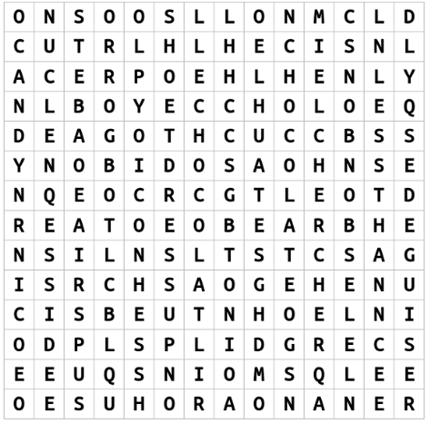

DICTÉE

A : ___________________________________________________________________________

______________________________________________________________________________

______________________________________________________________________________

______________________________________________________________________________

______________________________________________________________________________

______________________________________________________________________________

B : ___________________________________________________________________________

______________________________________________________________________________

______________________________________________________________________________

______________________________________________________________________________

______________________________________________________________________________

______________________________________________________________________________

2 sound/ symbol connection(s) I made : _____________________________________________

______________________________________________________________________________

2 sound/ symbol errors I made : __________________________________________________

______________________________________________________________________________

MESSAGE DU JOUR

Ma fille, Dorothy, aime se déguiser et chercher de la cochonnerie pour l’Halloween. Dorothy aime les bonbons autant que les chips. Elle aime le chocolat moins que les bonbons.

Answer the following questions (try for full sentences in French to reach extending!) :

- Comment s’appelle ma fille? _______________________________________________

______________________________________________________________________________

- Est-ce que Dorothy aime se déguiser pour l’Halloween? __________________________

______________________________________________________________________________

- Qu’est-ce que Dorothy aime autant que les chips? ______________________________

______________________________________________________________________________

- Qu’est-ce que Dorothy aime moins que les bonbons? ____________________________

______________________________________________________________________________

QUÉSTION DU JOUR

Sondage – respond using plus que, moins que and autant que

Ms. McDade | 1 | 2 | 1
Moi

Mon partenaire:

Write 3 sentences using your survery information. Use the expressions plus que, moins que and autant que at least once each.

Exemple: Ms. McDade aime les chips autant que les bonbons. Elle aime le chocolat moins que les bonbons. Dorothy aime les chips plus que le chocolat.

Ma réponse : _________________________________________________________________

______________________________________________________________________________

______________________________________________________________________________

______________________________________________________________________________

______________________________________________________________________________

______________________________________________________________________________

______________________________________________________________________________
AUTO-ÉVALUATION

MY BEHAVIOURS FOR SUCCESS FOR THIS COURSE WORK:
Behaviour | Self-assessment (circle)
Academic Responsibility: I seek help, complete assignments, set goals, self-assesses, accept feedback, take  ownership for my learning, I am organized | Consistently | Sometimes | Rarely
Engagement: I am ctive in learning, contributes to the classroom, work well with others | Consistently | Sometimes | Rarely
Conduct: I am respectful and focused | Consistently | Sometimes | Rarely

MY ACADEMIC ACHIEVEMENT:
Learning target 1: I ask and respond to questions in full sentences during question of the day and warm-up activities
EXTENDING (4) | PROFICIENT (3) | DEVELOPING (2) | EMERGING (1)
I speak without prompting and communicate my ideas clearly and confidently | I use conversation structures provided and sometimes require prompting | I use some modeled sentences and learned expressions and require a lot of prompting to do so | I use words rather than sentences in my conversations

Learning target 2: I can connect the sounds that I hear and the symbols that I write in a dictée exercize
EXTENDING (4) | PROFICIENT (3) | DEVELOPING (2) | EMERGING (1)
My written dictée mostly matched the actual written dictée. | I had some errors in my dictée but I made a lot of sound/ symbol connections. | My dictée and the actual written dictée have many differences. | My dictée and the actual written dictée look nothing alike

Learning target 3: I can write in full sentences using the expressions plus que, moins que and autant que
EXTENDING (4) | PROFICIENT (3) | DEVELOPING (2) | EMERGING (1)
I write in full sentences using the expressions correctly and add additional details | I write in full sentences using the expressions correctly | I can write in full sentences with the correct expressions some of the time | I use only short sentences or words

Learning target 4: I understand what I read in the message du jour
EXTENDING (4) | PROFICIENT (3) | DEVELOPING (2) | EMERGING (1)
I fully comprehend the texts and subtle details. | I comprehend the general meaning of the texts. | I understand some parts of the texts. | I do not understand the texts.

Comments from Ms. McDade:

