Name____________________________________________________________ Period__________

Lab Safety Meme Assignment
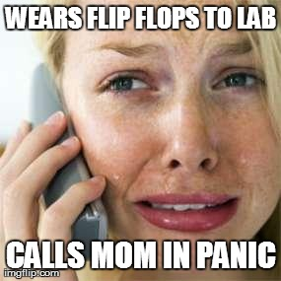

What’s a meme?
- A concept or catchphrase that spreads and changes from person to person

What’s your goal:
- Make a meme that reviews one lab safety rule
- Be as creative as possible!

How to make a meme:
- Go to https://imgflip.com/memegenerator (or any other meme site) and use stock photos or upload a photo to make a meme.
- Add your text, hit generate meme
- This will give you options to share via social media and will give you an image link

How to submit meme:
- Print it
- Email me the link of your meme at Kathleen.mcdade@yesnet.yk.ca

Rules:
- This is a school assignment, so only use appropriate pictures and language in your memes. If you are unsure if what you’re doing is appropriate, it probably isn’t…but you can always ask me before posting.
- Be creative! Be funny! If you are unsure where to start, look at other images in the meme gallery and figure out why they are funny or how they get the point across. (but remember to be original)
- If a lab safety meme has already been posted, you may not copy it, or you will receive zero points for the assignment.

Why are we doing this?
- Seeing a good meme will make you laugh, but creating a meme will really help you remember the science since you created in yourself.

Evaluation

Curricular competency: communication of scientific ideas
Not yet meeting expectation | Approaching expectations | Meeting Expectations | Exceeding Expectations
-Lab safety rule not evident | -Some evidence of lab safety rule presented  -Picture and text have minimal connection | -Lab safety rule is clear with appropriate text and picture | -Lab safety rule is clear, original and thought provoking  -Text of meme matched tone and content of meme picture

If you don’t complete your meme during class time, you must complete it for homework. If you do not have access to a computer or the internet at home, complete this activity in the school library before/ after school or during lunch/ break time.

