Le Jour du Souvenir
Core French 8 – McDade

SECTION 1: VOCABULARY

Look up the English translations for the following French words related to le Jour du Souvenir (Remembrance Day) using wordreference.com. Indicate whether the word is a noun (include gender) or a verb. This information will be visible on wordreference.com. Complete the word searches on the next two pages

French word | English word | Noun or Verb | For nouns, masculine or feminine
paix | peace | noun | feminine
Canada
merci
novembre
soldat
coquelicot
poème
veteran
se souvenir
silence
courage
croix
monde
héros
uniforme
couronne
liberté
drapeau
fierté
honorer

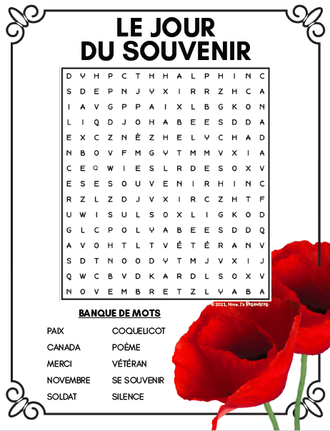

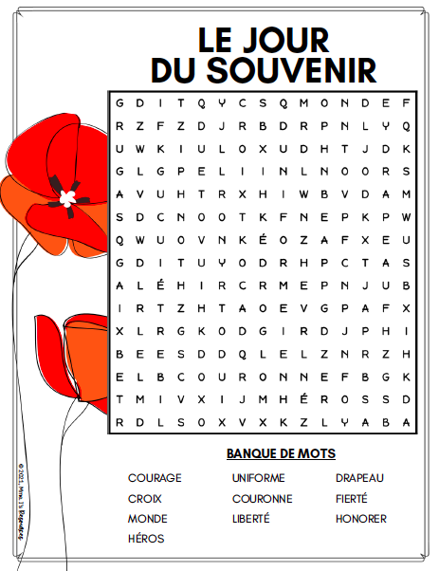

SECTION 2: INDIGENOUS VETERAN READING AND QUESTIONS
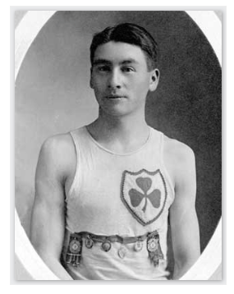
Alexander (Alex) Wuttunee Decoteau was born on the Red Pheasant Reserve in Saskatchewan in 1887. His father was Métis, and his mother was Cree. He moved to Alberta as a young man and became our country’s first Indigenous police officer when he joined the Edmonton force in 1909!
Alex was a remarkable long-distance runner and he won most of the major races in Western Canada during his athletic career. He even qualfied to represent Canada and compete in the 5,000-metre race at the 1912 Olympics in Stockholm, Sweden! He made it to the finals but, unfortunately, suffered leg cramps which affected his performance.
When the First World War was raging, Alex enlisted in the Canadian Army in 1916. He served with the 202nd Infantry Battalion (known as the Edmonton Sportsman's Battalion) and later with the 49th Battalion. His running skills were put to good use in his role as the battalion messenger, a very dangerous job of running messages across battlefields in the face of enemy fire. This did not stop him from running in races however. In fact, he continued to run and entered military races in England, where his group was training. At a military sports event in England (which were common distractions from war for the soldiers at the time) he won a five-kilometre race. King George V was watching the event and awarded him with his own personal gold pocket watch as a prize! He treasured this special watch and kept it in his pocket.
During the fall of 1917, Private Decoteau fought with the Canadian troops through endless rains and knee-deep mud to capture the small town of Passchendaele (pronounced Pa-chen-dale) in the country of Belgium. By November 10, 1917, the Canadians were successful in capturing the village from the Germans. However, the Battle of Passchendaele was one of the worst battles of the First World War and success came at a great cost. Approximately 16,000 Canadians were killed or wounded. A century later, the Battle of Passchendaele is remembered as one of the worst horrors of the First World War.
Tragically, one of those Canadians was Private Decoteau. He was killed on October 30, 1917 just before his 30th birthday. It is said that the German sniper who shot him kept the special watch that the King had awarded to Alex. However, his friends later recovered the treasured watch and sent it home to Decoteau’s mother.
Private Decoteau was buried in the Passchendaele British New Cemetery in Ypres, Belgium, overlooking the pastoral farmers' fields that spill out over the Belgian countryside. A small rose bush sits just to the right of his grave. In his memory, Alex Decoteau remembrance runs are held every year in Canada and Belgium.
- Where and when was Alex Decoteau born?

- ***Alex’s dad was Métis and the official language of the Métis Nation is Michif. Go to albertametis.com/culture/language to find out how Michif is connected to French and Cree languages.

- What were some of Alex Decoteau’s accomplishments?

- Alex Decoteau served in the Canadian Army during which world war?

- Alex Decoteau died during the Battle of Passchendale? When did he die? When did the battle end?

- ***Look up the Battle of Passchendale list 5 things you learned about it.
1)
2)
3)
4)
5)

- ***On the map below, indicate the approximate location of the Battle of Passchendale.
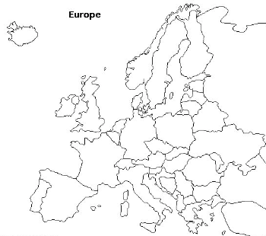

- In his memory, what happens every year in Canada and Belgium?

