"Au" Canada
French 8 – Ms. McDade

SECTION A – COUNTRIES (LES PAYS)

In the French language, countries are either masculine or feminine. Canada is masculine so we refer to it as “Le Canada” in French. Countries are also sometimes spelled differently in French than in English. To replace the word “in” when we are referring to where we are born, we use different gender-based prepositions in French. Fill in the blanks with the correct words:

- Je suis née _________________ Canada. MASCULINE
- Il est né ________________ France. FEMININE
- Elles sont nées ________________ Etats-Unis. PLURAL
- Iels sont nés _________ Madagascar. ISLAND EXCEPTION

Let’s do a few more examples together as a class :

Country (English) | Country (French) | « Je suis née… » sentence

SECTION B – PROVINCES/ TERRITORIES (PROVINCES/ TERRITOIRES)

Provinces/ territories are also either masculine or feminine. Like countries, they are also sometimes different than English words. Fill in the table with the French name of each province/ territory and the correct masculine or feminine preposition.

English name of province/ territory | French name of province/ territory | “In” Preposition | Couleur
British Columbia |  |  | Rouge
Alberta |  |  | Jaune
Saskatchewan |  |  | Bleu
Manitoba |  |  | Orange
Ontario |  |  | Vert
Québec |  |  | Brun
New Brunswick |  |  | Rouge
Nova Scotia |  |  | Jaune
Prince Edward Island |  |  | Bleu
Newfoundland and Labrador |  |  | Vert
Yukon |  |  | Violet
Northwest Territories |  |  | Rose
Nunavut |  |  | Gris

SECTION C - MAP

- Complete the blank map of Canada by labelling the provinces and territories in French.
- Colour each province/ territory as indicated in the table above
- Using a dot, label the city in which you were born
- Write a sentence on the bottom of your map to indicate where you were born ***Note that we always use the preposition “à” to indicate “in” with respect to cities.
  - e.g. Je suis née à Saint John, au Nouveau Brunswick.
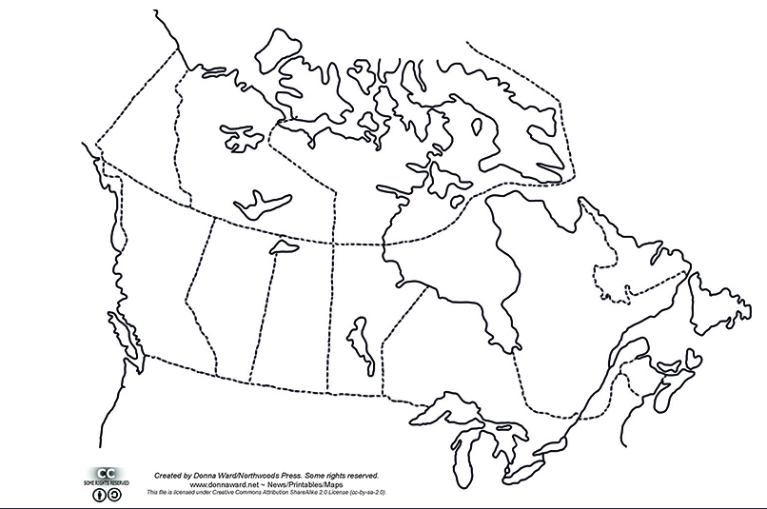

SECTION D – THE VERB "NAÎTRE”

The verb “naître” in French means to “be born.” It is used most often in the past tense (e.g. I was born…). Different pronouns have different conjugations in French. Fill in the following table:

English Pronoun | English Verb | French Pronoun | French Verb
I | was born
You (singular) | were born
He (masculine singular) | was born
She (feminie singular) | was born
They (nonbinary singular) | were born
We (informal) | were born
We (plural) | were born
You (plural) | were born
They (masculine plural) | were born
They (femininie plural) | were born
They (nonbinary plural) | were born

- There are multiple past tenses in French. This one is called
- Because the first part of the verb is ___________________, the second part needs to agree with the first (masculine/ feminine/ plural)
- Masculine/ nonbinary singular: ___________________________________________
- Masculin/ nonbinary plural: ___________________________________________
- Feminine/ nonbinary singular: ___________________________________________
- Feminine/ nonbinary plural: ___________________________________________

SECTION E: CLASS DETAILS
e.g. Ms. McDade est née à Saint John, au Nouveau Brunswick

