Nom:

Croissants et Pains au Chocolat
Core French 8

VOCABULAIRE

FRANÇAIS | ANGLAIS

LES VERBES LES NOMS

- -

- -

-

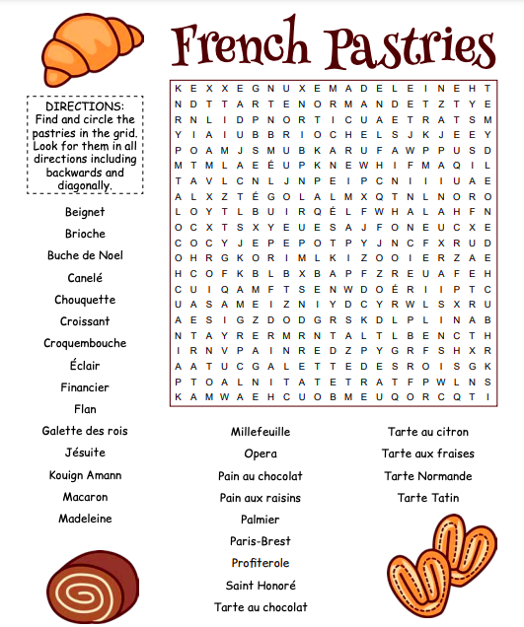

- Look up these words and provide the translations beside the words listed where appropriate. Provide diagrams as needed.

- Pick one of the pastries from the word search, look up a video on how to make the pastries and briefly describe the process below:

LA RECETTE -es pains au chocolat et les croissants:

- ______________ hands
- ______________ work surface
- Preheat oven to 375 degrees
- Lightly flour work surface
- Get baking pan from bottom drawer of oven and cover with parchment paper
- Roll sheet of pastry to ~16 inches long
- ________________ pastry in half along long edge
- ________________ rectangular strips of pastry for pains au chocolat
- Add chocolate near end of pastry strips, roll once, add more chocolate and finish rolling
- Place uncooked pains au chocolat on parchment paper, spaced out by a few fingers, and press gently
- With remaining dough, cut into _____________________, make a small slice in the middle of long edge, stretch slightly lengthwise
- ________________ croissants from long edge to point
- Place uncooked pains au chocolat on parchment paper, spaced out by a few fingers, and curve edges slightly
- Glaze tops of pastries with ________________ or ________________/ beaten egg mixture
- Let pastries rise
- Add more glaze
- Cook pastries for ~15 minutes
- Let cool and clean up your workspace by cleaning all dishes, disposing of parchment paper in compost and wiping down all work surfaces
- ________________hands and enjoy your pastries!
AUTO-ÉVALUATION

MY BEHAVIOURS FOR SUCCESS FOR THIS COURSE WORK:
Behaviour | Self-assessment (circle)
Academic Responsibility: I seek help, complete assignments, set goals, self-assesses, accept feedback, take  ownership for my learning, I am organized | Consistently | Sometimes | Rarely
Engagement: I am active in learning, contributes to the classroom, work well with others | Consistently | Sometimes | Rarely
Conduct: I am respectful and focused | Consistently | Sometimes | Rarely

MY ACADEMIC ACHIEVEMENT:

Learning target 5: I engage in cultural activities
EXTENDING (4) | PROFICIENT (3) | DEVELOPING (2) | EMERGING (1)
I am fully engaged when watching movies in French, doing art projects in French and learning about French culture | I am mostly engaged when watching movies in French, doing art projects in French and learning about French culture | I am somewhat engaged when watching movies in French, doing art projects in French and learning about French culture | I am not engaged when watching movies in French, doing art projects in French and learning about French culture

